Fatima College of Health Sciences

FRD 4082 : WORKBOOK

Finding information for your
Literature review

FIND YOUR LIBRARY CONTACT:
PLEASE COMPLETE WITH FATIMA PERSONNEL

Find your MNHS Faculty contact librarians at: monash.edu/library/skills/contacts/fac-medicine.html

Literature searching

A literature search is a scan of the literature to locate information on a particular topic. The aim can be to carry out a comprehensive search to locate all published articles/studies/reports, or a quick search to locate a small selection of studies.

For comprehensive literature searching it’s important to be systematic in your approach. This includes developing a plan for your search (including the search terms you will use and the resources you will search), and keeping records of the searches you carry out.

Searching the literature helps you:
- gain an overview of a topic
- find out what is known already and how your own topic relates to this
- avoid repeating research that has already been carried out
- keep up to date

Note:
This session will not be concentrating on the methods and guidelines used in undertaking a systematic review. The following resources may assist you in the initial stages of conducting a systematic review of the literature. Further advice is available from your subject librarian:

- What is a Systematic Review? http://eppi.ioe.ac.uk/cms/Default.aspx?tabid=67
- Cochrane Collaboration systematic reviews and protocols http://www.cochranelibrary.com/about/about-cochrane-systematic-reviews.html
- EPPI-Centre methods for conducting systematic reviews http://eppi.ioe.ac.uk/cms/LinkClick.aspx?fileticket=hQBu8y4uVwI%3d&tabid=88
- PRISMA statement and checklists http://www.prisma-statement.org/
- Campbell Collaboration training videos on the purpose and basic elements of systematic reviews http://www.campbellcollaboration.org/resources/training/The_Introductory_Methods.php
- An evidence-based practice guideline for the peer review of electronic search strategies http://www.sciencedirect.com/science/article/pii/S089543560800320X

Information sources
The type of information you’re looking for will determine the best places to search. A selection of resources is highlighted below, and in the subject library guides (www.lib.monash.edu.au/subjects/ ) on the library website.
Please complete with FATIMA information

Preliminary research

Books and review articles can be useful for gaining an overview of a topic or a particular aspect of your research. You may find it is helpful to begin your research with a broad, preliminary search of some key databases to familiarise yourself with the topic and to determine the quantity of literature on this topic. This “scoping” search can also help to identify additional key terms that can be incorporated into your search strategy. Google Scholar, Scopus and OVID Medline are popular choices for this kind of searching – you can access these databases from the Popular Databases listing on the library databases page at: http://guides.lib.monash.edu/subject-databases

Note: Check if the library can provide access to full text articles in Google Scholar by following the instructions at: http://guides.lib.monash.edu/check-for-full-text/google-scholar

Key databases and search engines

A comprehensive review of the literature requires searching a number of databases individually. A list of databases for health related topics can be found in:
Please complete with Fatima information
- The Databases by Subject library guide at: http://guides.lib.monash.edu/subject-databases
- Relevant subject-based library guides at: www.lib.monash.edu.au/subjects/
- The Databases link in the library’s Search Tool at: http://search.lib.monash.edu/primo_library/libweb/action/search.do?vid=MON

Search engines provide an important access point for grey literature and specific organisation websites. Refer to the Academic Research on the Internet tutorial for strategies to develop more effective searching and evaluation techniques for the web: http://www.monash.edu/library/skills/resources/tutorials/academic-research-internet

Theses

The Monash University Library Theses library guide provides resources and guidelines for locating and accessing theses produced by Monash University as well as other universities in Australia and internationally: http://guides.lib.monash.edu/theses

Guidelines

Clinical guidelines are written to assist health professionals and patients in making informed, evidence-based decisions about the best healthcare for a specific condition or situation.

Sources of guidelines include:

- Clinical practice guidelines portal (Australian) www.clinicalguidelines.gov.au/
- MJA Clinical Guidelines www.mja.com.au/public/guides/guides.html
- NHMRC guidelines www.nhmrc.gov.au/guidelines/search
- National Guidelines Clearinghouse (US) www.guideline.gov/
- NICE clinical guidelines (UK) www.nice.org.uk/guidance/index.jsp?action=byType&type=2&status=3
- ETG Complete - Therapeutic guidelines (Australian) http://guides.lib.monash.edu/go.php?c=8479518

Trials

Trials registries provide a list of publicly and privately supported clinical studies that have been conducted or are currently underway:

Australian and New Zealand Clinical Trials Registry (ANZCTR):
http://www.australianclinicaltrials.gov.au/clinical-trial-registries
- ClinicalTrials.gov: http://clinicaltrials.gov/

Grey literature

Grey literature is information which has been either published informally or non-commercially, or remains unpublished. It can include a range of material, such as government or technical reports, discussion papers, statistics, conference proceedings and policy documents. Additional grey literature document types are listed at: http://www.greynet.org/greysourceindex/documenttypes.html .

Some key grey literature sources include:

- OpenGrey (European): http://www.opengrey.eu/

New York Academy of Medicine grey literature report (US)
http://www.greylit.org/home
- Search engines such as Google, or browse specific organisation websites

Statistics

Current statistical data can be found in the following sources, however additional statistics are available from many government websites and also from the library’s Statistics database guide at: http://guides.lib.monash.edu/subject-databases/statistics

- Australian Bureau of Statistics: http://www.abs.gov.au/websitedbs/D3310114.nsf/home/home. Details regarding access to “Table Builder” are available at: http://www.abs.gov.au/websitedbs/D3310114.nsf/home/CURF:+ABS/Universities+Australia+CURF+A greement?OpenDocument

Department of Health, Australian Government:
www.health.gov.au/internet/main/publishing.nsf/Content/Statistics-1
- Australian Institute of Health and Welfare: www.aihw.gov.au/
- World Health Organization: Health Data and statistics: http://www.who.int/healthinfo/statistics/en/

Laboratory protocols

Protocols (or standard operating procedures) provide instructions for the recreation or duplication of experiments. A list of laboratory protocols is available on the Medicine library guide at: http://guides.lib.monash.edu/c.php?g=219702&p=2959055

Useful books

- Booth, A. (2012) Systematic approaches to a successful literature review. London: Sage
- Garrard, J. (2011) Health sciences literature review made easy: the matrix method.(3rd ed.) Sudbury, MA: Jones & Bartlett Learning
- Ridley, D. (2008) The literature review: a step-by-step guide for students. Los Angeles: Sage

Systematic searching strategies

It is necessary to be systematic in your approach to searching:

- Define your research question, including eligibility criteria
- Develop your search plan
- Test and Refine your search
- Apply limits
- Select relevant resources
- Run your search in each database/resource
- Document and manage the search results
  - Keep detailed records of your searches
  - Use software such as EndNote to store and organise your references
  - Set up alerts to new publications
- Consider additional sources such as Grey Literature or Citation searching

Note: When writing a systematic review you will need to document:
- Methods - the literature search and the full electronic search strategy of at least one database
- Results - a flow chart outlining the number of studies retrieved, reviewed, excluded and included

Define your research question
Before you begin searching, define your topic, even if you haven’t determined the exact focus of your research yet. Do background research to extend your understanding of the research area and the terminology used in its discussion.

Example

Scenario:
Although it is well-accepted that hand hygiene is a critical patient safety practice for reducing healthcare- associated infections, compliance with this practice amongst health care professionals is often low, and evidence demonstrating which interventions are most effective for increasing this compliance is lacking.

Define your question:
- What strategies are effective for increasing handwashing compliance amongst health care professionals?
PICO framework can be used to define clinical questions.
eg. For health care professionals (P), how effective are handwashing strategies (I) on increased handwashing compliance (O)?
Patient/population:
Intervention: Control/comparison: Outcome:
health care professionals
strategies for hand washing compliance none
increased hand washing compliance

Develop a search plan
Planning a search before you start will improve the results; however you may have to refine or adjust your search strategy depending on the initial results. A tutorial outlining the principal steps of effective searching is available from: http://monash.edu/library/skills/resources/tutorials/searching/.

- Break the topic into major concepts (there are usually between 2-4 concepts)
Search concept 1: handwashing
Search concept 2: health care professionals Search concept 3: compliance

Identify the main search terms (including alternative spellings and synonyms) for each concept
  - Refer to specialist reference material eg thesauri
  - Perform initial searches to create a “sample set” of relevant papers – mine these papers for key terms

Use some/all of the following tips to develop your search strategy

Combine search terms with OR/AND/NOT
  - Combine synonyms with OR
  - Combine different concepts with AND
  - Exclude specific terms with NOT

Use Proximity symbols/operators to specify the closeness of one term to another.
eg. hand*adj3 washing in OVID finds terms in any order with two words (or fewer) between them. Proximity operators vary in each database - See handout for details.
Use quotes to search for phrases eg. “hand washing”
Use symbols to retrieve word variations (Note: the symbols vary in different databases) eg. complian* will retrieve compliance, compliant, etc
organi#ation will retrieve organisation or organization
Identify useful limits eg. English language

A sample search strategy that could be applied to different databases is shown below. This is an example only, and would need further development to be a comprehensive strategy.
Concept 1 Concept 2 Concept 3
complian*
handwashing OR
“hand washing”

OR
“hand hygiene”

nurse* OR
“health care professional*” OR
doctor*

AND AND

Improve the quality of your Searches using the following checklist:
Search Appraisal 10 point checklist: http://epoc.cochrane.org/sites/epoc.cochrane.org/files/uploads/08%20How%20to%20develop%20a%20search%20strat egy%20%28May%202014%29_0.pdf

Search methods

Keyword (or textword) searching
Search the title and abstract of the records in a database. Other fields may also be searched, however the title and abstract fields are generally included regardless of which database you are searching. It’s important to include alternative spellings and synonyms, and to make use of truncation to retrieve all articles on your topic. Proximity symbols can also be used.

Subject searching
In some databases, the records are tagged with “subject headings”, which describe the content of the article. If you search for and find a relevant subject heading, this will link you to all of the articles in the database with that subject heading. One advantage of subject searching is that you can locate articles that use synonyms and alternative spellings.

Combined keyword and subject searching
This is the most comprehensive way of searching as it is highly unlikely that key word or subject searching alone will retrieve all relevant records.

Citation searching
Search for a specific article in Scopus, Web of Science or Google Scholar, to find more recently published articles, which cite the article. This technique is also referred to as “snowballing” – using one reference to uncover other references about the topic.
You can also access the electronic references cited in the specific article.

Author searching
If you’re aware of a prominent researcher/author working in your field, search a database to identify all of the articles they have published.

Activity 1: Keyword searching in Scopus
- Login to Scopus at http://guides.lib.monash.edu/go.php?c=8480086

Enter handwashing OR “hand washing” OR “hand hygiene” and click on the search icon. Note: You can specify which fields you wish to search for these terms

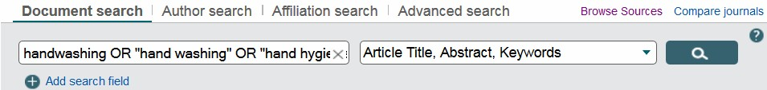

Click on the Search link at the top left of the screen to return to the search box.
Enter “health care professional*” OR doctor* OR nurse* and click on the search icon.

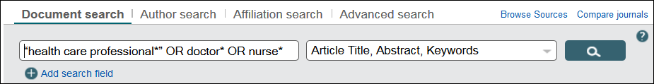

Click on the Search link at the top left of the screen to return to the search box. Enter complian* and click on the search icon.

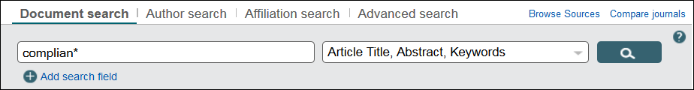

- Click on the Search link at the top left of the screen to return to the main search page. The three search sets can now be combined using the Search History menu.

Enter the search set numbers into the Combine queries… box, with AND between each set, and then click the search icon.

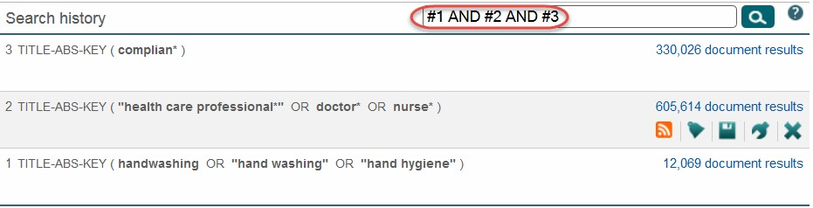

- In the Refine results table on the side of the results, choose Language. Click the down arrow to expand the menu. Tick English, then the Limit to button.

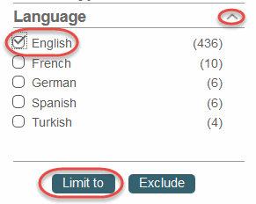

- Use the Sort on links to change the order of the results. Select the Relevance link.



- Review your results and adjust your search if necessary.

You can test your initial search strategy in the following ways:

Does it retrieve relevant papers?
  - Does it retrieve the papers from your “sample set”?

- If you retrieve too many results, try:
-using more specific search terms
-using limits
-adding another term and combining with your previous result set using and
- If you are not finding any or only a few results, try:
-using more general search terms
-removing limits eg. publication year
-checking a known reference for alternative keywords
-a different database

- Locate full text using the Check for full text button

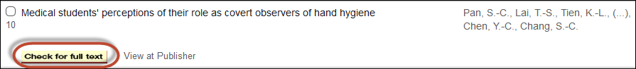

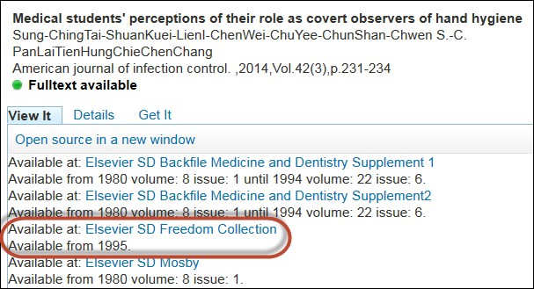
Click on this link to open the full text of the article.
If full text is not available online, the following Search window will appear

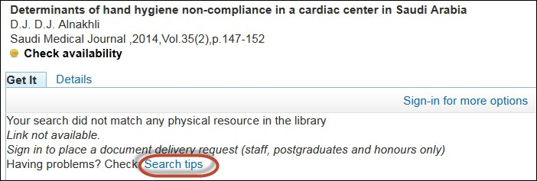
Full text links are not shown for this article.
Click Search tips to try an alternative search for the full text of this article. If your search still does not match any resource in the library, sign in to place a document delivery request for this item.

Activity 2: Subject searching in Ovid Medline
In Ovid Medline each record is tagged with MeSH (Medical Subject Headings) which are selected from a controlled list and describe what the article is about. An Ovid Medline record in the Complete Reference format is shown below. Note the list of MeSH (Medical Subject Headings) assigned to the article.

Advantages of subject searching:
  - Helps locate articles that use synonyms, variant spellings, plurals
  - Subject headings can be “exploded” to include more specific terms
  - Search terms don’t have to appear in the title or abstract

Note: Subject Headings differ between each database, so it is important to run a subject search for each database that you use – the subject terms are not transferable.

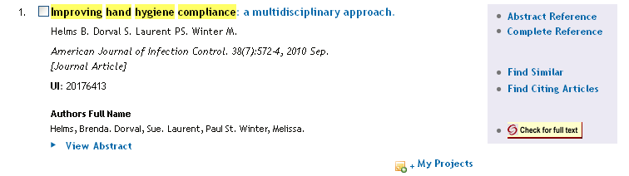

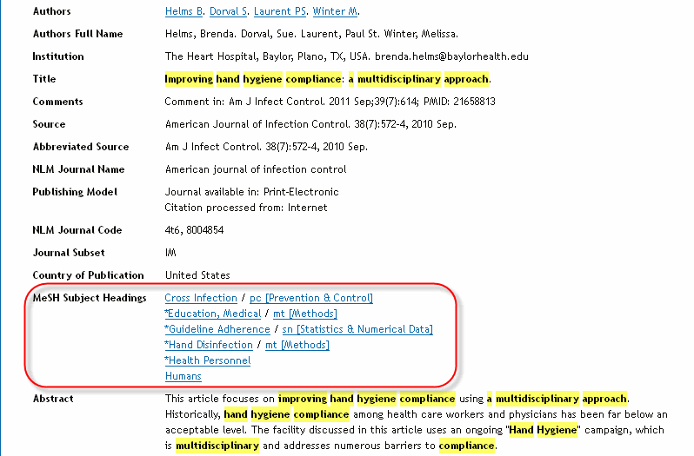

- Login to Ovid Medline at http://guides.lib.monash.edu/go.php?c=8479877

- Enter handwashing, tick the Map Term to Subject Heading box, and click Search.

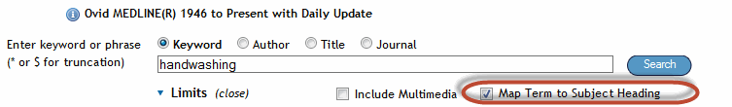


Your search term is mapped to a Medical Subject Heading (MeSH) if possible. Handwashing is not a subject heading that is used in this database. The subject heading suggested is Hand Disinfection.

Click on the Scope note next to Hand Disinfection for more details, including a definition of this term. Note handwashing is in the list of synonyms under Used for. After confirming it is appropriate, click on the link for this subject heading.

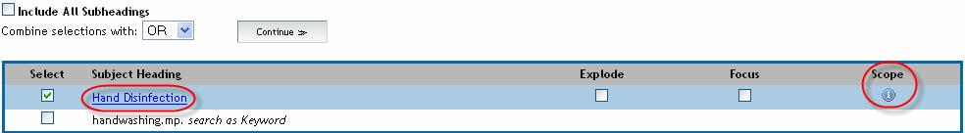

The subject heading tree is displayed. Look for any relevant narrower or broader terms for Hand Disinfection. In this case, the broader term Hand Hygiene would also be a relevant search term. Select both Hand Disinfection and Hand Hygiene. Click Continue.

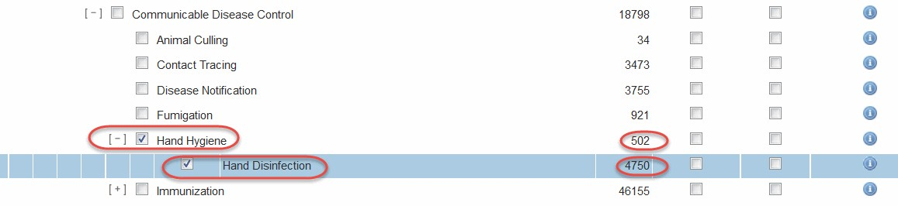
This number is the number of articles indexed or ‘tagged’ with this subject heading.
- Enter health care professional, ensure the Map Term to Subject Heading box is ticked, and click Search. Hint: Also check other “composite” terms eg. healthcare professional

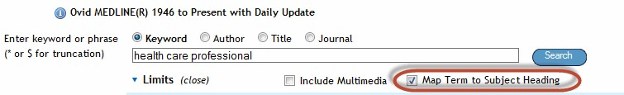

Health care professional is not listed as a subject heading. Scan the list of suggested headings, click on the
Scope notes for further information. Click on the link for the subject heading Health Personnel.

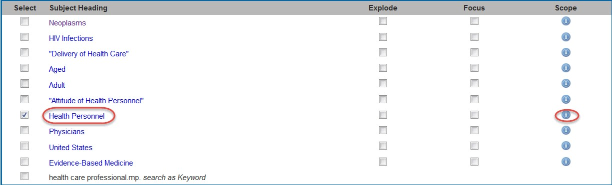

A section of the subject heading tree is displayed. Note the more specific (or narrower) terms listed underneath Health personnel. To include all of these more specific terms, tick the Explode box next to Health Personnel, then click Continue. Narrower terms will not be automatically included in your search if they are not individually ticked, or if the explode box of the broader term is not ticked.

Tip: Tick the Focus box if you wish to limit your search to only those documents in which your subject heading is considered the major point of the article. This is not recommended for comprehensive searches.

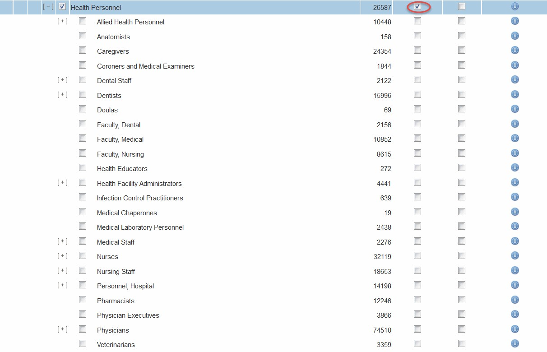

A list of subheadings is displayed. Select Include All Subheadings, and click Continue for a comprehensive search.



- Enter compliance, ensure the Map Term to Subject Heading box is ticked, and click Search.

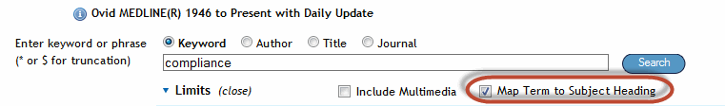

The subject heading Compliance is suggested; however, if you look at definition in the Scope note, this is not appropriate for our question:

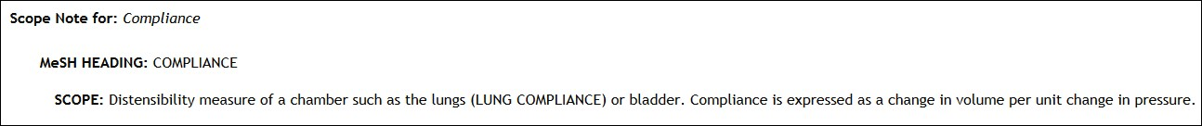

In this case, you can choose to search for compliance as a keyword by selecting compliance.mp. search as Keyword. However this is not recommended because the search will not look for variant endings of this keyword such as compliant.

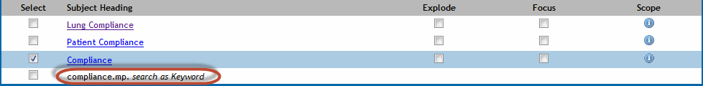

Go back to the main search page, and enter complian*. UNTICK the Map Term to Subject Heading box to revert to a keyword search.

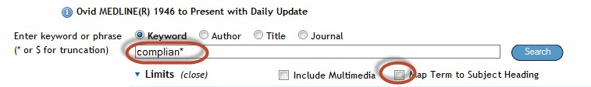

- Go to the Search history and combine the separate search sets with And

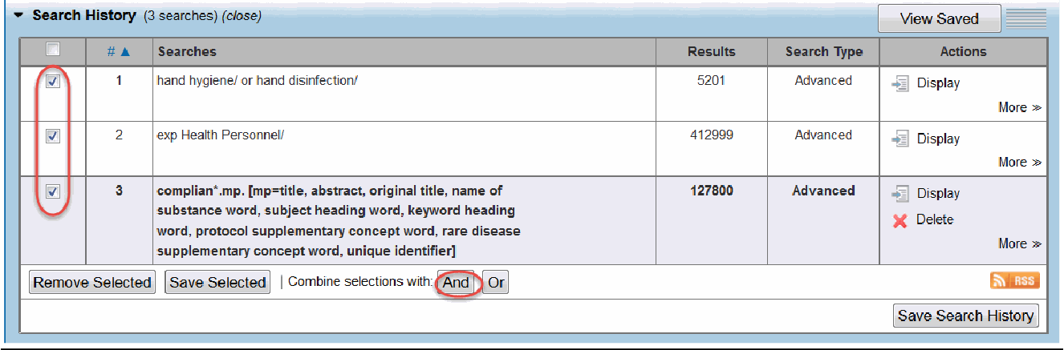

- Tick the English language limit, and then click Search. This limits the last search result in the Search History. There are many more limits available if you click on the Additional limits button.

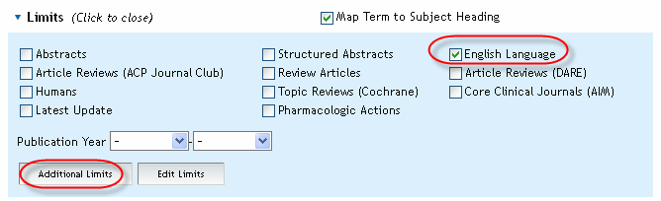

- Review your results and refine your search if necessary. Note that the results are listed in order from newest to oldest (not relevance).
Tip: For articles that are very relevant to your topic it can be helpful to look at the Complete reference in Ovid Medline to see which MeSH have been selected. You may find relevant MeSH that can be added to your search strategy to help find similar articles.

Combined keyword and subject searches
For a comprehensive search you will need to combine keyword and subject searches. Note that a combined search will usually retrieve more records than a subject or keyword search alone. In this instance the OVID Medline subject heading search retrieved around 434 records, and the following combined keyword and subject search retrieved 572 records.

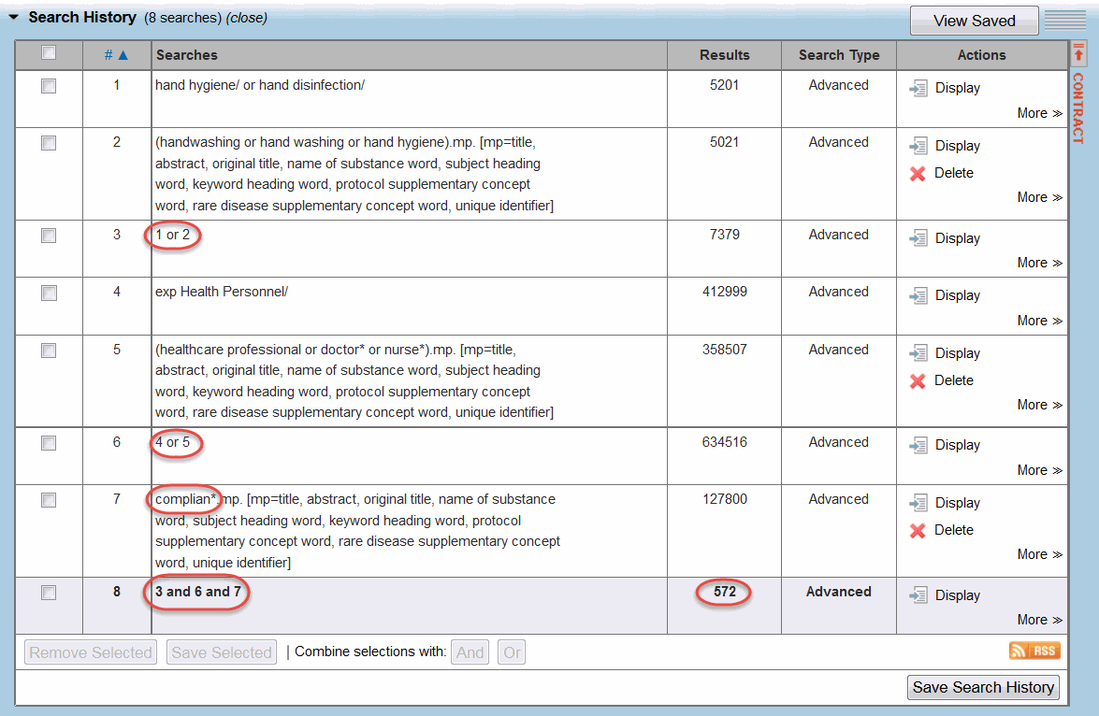

Activity 3: Citation searching in Scopus
Search for the following article in Scopus, to check how many times it has been cited and see if any of the newer articles are relevant to this topic.

Pittet, D 1999, Compliance with handwashing in a teaching hospital, Annals of internal medicine, 130(2), 126-30.
- Login to Scopus at http://guides.lib.monash.edu/go.php?c=8480086
- Enter the article title “compliance with handwashing in a teaching hospital” and click the search icon.

- How many times has this article been cited? Click on the number in the Cited by column to view the list of newer articles.
- Click on Analyze search results. You can then analyse the strength of specific journals in the field, identify prominent authors and their affiliations, and pinpoint principle subject areas for this query.



Document and manage your search results
It is important to keep good records of the searches you carry out, to avoid having to repeat them again later. There are various ways of doing this. One method is to save copies of your search histories within each database. To do this you generally need to set up a free personal account in each relevant database - look for a link at the top right of the main search page. Alternatively you may choose to create a spreadsheet or search diary to record the details of your searches.

Keep up to date with new research

Once you have completed your initial literature searches you can set up alerts to receive an email on a regular basis (eg. weekly) with a list of new articles that match your search query.

If there are key journals in your field, it might be useful to set up email alerts to receive notification when a new issue is released. These emails contain a list of all of the articles in the issue, which makes it easy to scan the titles and decide if there are any articles worth following up.

Academic and professional networking sites can also alert you to relevant new research, and provide a platform to create a profile, share papers, monitor citation metrics and identify collaborative opportunities in particular research fields. These sites include Academia.edu (http://www.academia.edu/), ResearchGate (http://www.researchgate.net/) and LinkedIn (https://au.linkedin.com/). Refer to the “Researcher Profiles” tab of the Research Impact and Publishing library guide at: http://guides.lib.monash.edu/research-impact- publishing/researcher-profiles

Example: Setting up a personal account in Ovid Medline

  - Login to Medline at http://guides.lib.monash.edu/go.php?c=8479877. At the top right of the screen click on My Account.

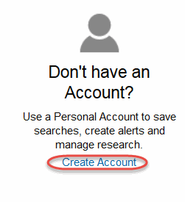
  - On the next screen, click on Create Account.

  - Fill in the required fields, and then click Create.

Example: Saving a search strategy and setting up an email alert in Ovid Medline

- Login to Ovid Medline at http://guides.lib.monash.edu/go.php?c=8479877

- Login to My Account. Click on the Search tab, and then carry out your search.

- When you have developed a good search strategy and it gives you a reasonable number of results, go to the Search History and click on Save Search History.

0655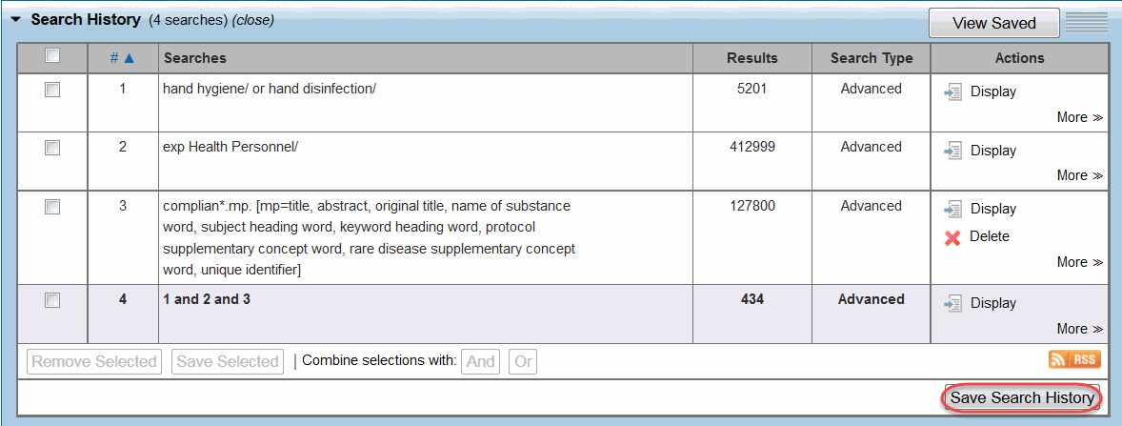

- If you are not already logged into your My Account, you will be prompted to login.
- On the Save Current Search page, add a Search Name, Comments (eg. date you created the alert) and choose Autoalert(SDI) from the Type drop down list.
Choose from the range of options, then click Save.

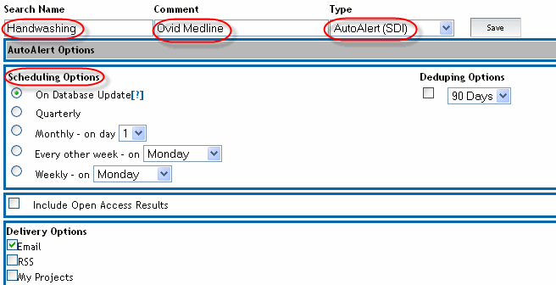

Example: Viewing/ editing an email alert search strategy in Ovid Medline

- Login to Medline at http://guides.lib.monash.edu/go.php?c=8479877



- Look at your AutoAlert (SDI) Searches, and choose from the options available. Click the Eye icon to
display the strategy, or the pencil icon to edit the strategy.
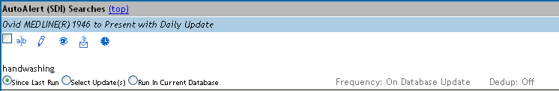

Develop a search plan and search for articles for your own topic

What is your question?

  - Identify the main search terms, including alternative spellings and synonyms. Combine search terms with or/and, use quotes and truncation where needed.

Note: Depending on the topic/question, between 2 to 4 concepts is a good number to start with. Concept 1 Concept 2 Concept 3
OR
OR
OR
OR
OR
OR

AND AND

What limits will you apply?

  - Select 2 relevant databases for your search. Refer to the library databases listing at: http://guides.lib.monash.edu/subject-databases

